

TASK
Exploratory Data Analysis on the ************ Dataset



Introduction
Summary of the data set

Matric Results Dataset EDA Report
Introduction: In this report, we will be performing an EDA on the matric results dataset. The objective of this EDA is to understand the underlying patterns, relationships, and trends in the data. We will be using the Python programming language, and the following libraries: pandas, seaborn, and matplotlib.
Dataset Description:The matric results dataset contains information about the number of learners who wrote and passed matric exams in 2016, broken down by quintile. The quintile variable is a measure of socio-economic status, with quintile 1 being the lowest and quintile 5 being the highest. The dataset has 5 variables and 39 observations.

DATA CLEANING

# SUMMARY OF THE METHODS AND VISUALISATIONS DONE DURING DATA CLEANING
We start by loading the dataset into a pandas DataFrame using the read_csv() method. We then use head(), tail(), info(), and isnull().sum() methods to get an overview of the data.
We observe that there are no missing values in the dataset, and we remove any duplicate rows using the drop_duplicates() method.

MISSING DATA

# ANY MISSING DATA? HOW DID YOU HANDLE IT
We observe that there are no missing values in the dataset.

DATA STORIES AND VISUALISATIONS

# THIS IS THE BULK OF THIS PROJECT. EXTRACT STORIES AND ASSUMPTIONS BASED ON VISUALISATIONS OF THE DATA
Univariate Analysis: We perform univariate analysis using a histogram to visualize the distribution of the quintile variable. We observe that most of the students are from quintiles 1 to 3. This indicates that the majority of the students come from lower socio-economic backgrounds.
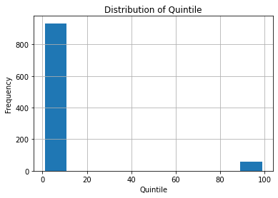
Bivariate Analysis: We perform bivariate analysis using a box plot to visualize the relationship between the quintile variable and the percentage pass variable. We observe that there is a slight decrease in percentage pass as we move from quintile 1 to 5. This indicates that students from lower socio-economic backgrounds may have lower performance in matric exams.
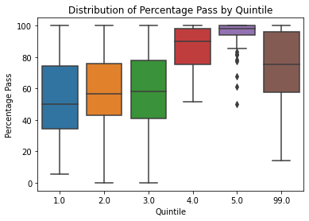

We also perform bivariate analysis using a scatter plot to visualize the relationship between the number of learners who wrote and passed in 2016. We observe a strong positive correlation between the two variables, which indicates that the number of learners who pass increases with the number of learners who write.
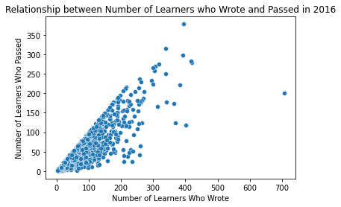
Multivariate Analysis: We perform multivariate analysis using a pair plot to visualize the relationship between different variables based on the quintile. We observe that the variables are highly correlated for all quintiles. This indicates that there is a relationship between the number of learners who wrote and passed in 2016, the percentage pass, and the quintile.
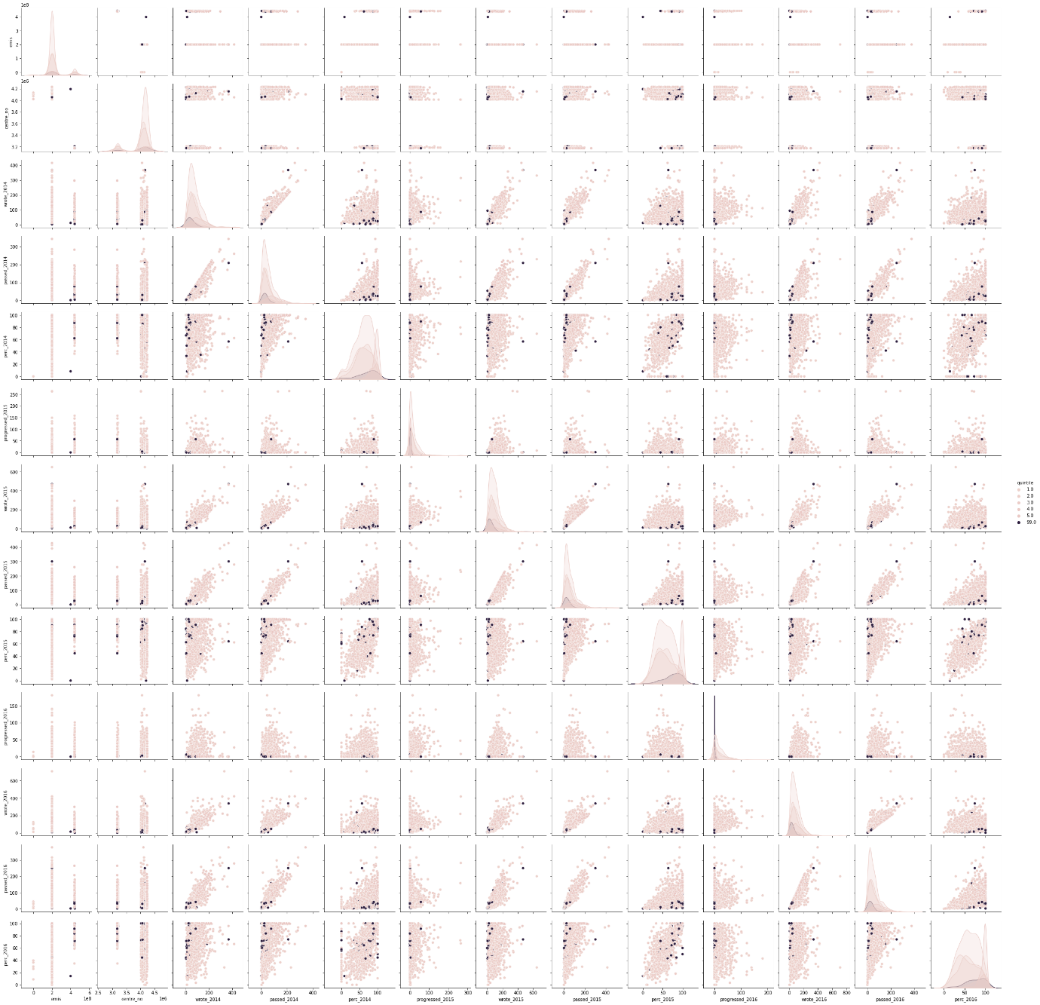
Correlation Analysis: We create a correlation matrix using the corr() method and visualize it using a heatmap. We observe that the percentage pass variable is strongly correlated with the number of learners who wrote and passed in 2016. This further confirms the strong relationship between these variables.
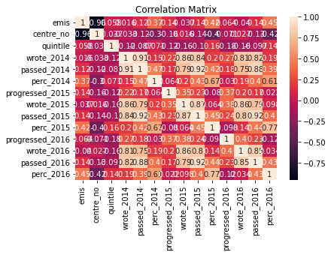
Conclusion: This EDA provides some interesting insights into the matric results dataset. We can conclude that the number of learners who write and pass is strongly correlated, and that there is a slight decrease in percentage pass as we move from quintile 1 to 5.

# ENSURE THIS DOCUMENT IS NEAT AND ADD IT TO YOUR PORTFOLIO

THIS REPORT WAS WRITTEN BY : Mfesane Kunju

